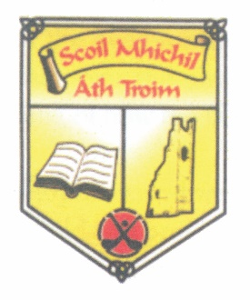
St. Michael’s National School,
Patrick Street,
Trim,
Co. Meath.
C15FK19
Roll No. 05630L
Tel: 046 9431813
Email: scoilmhichil@gmail.com

Application for Admission to Special Classes

Please note that this form is for application purposes only. The information provided will be used to allocate available places in accordance with the School’s Admission Policy/Annual Admission Notice (www.stmichaelsnstrim.ie)
Please complete all sections of this form.

General Information on Child
First Name: | Surname:
PPS Number: | DOB: | Gender:
Home Address:

Eircode:
/

Siblings in the school: Yes No (Please tick)
Name(s) of sibling(s) – please include the sibling(s) current class(es)

General Information on Parent(s)/Guardian(s)
Parent/Guardian | Parent/Guardian
Name: | Name:
Address (if different from child’s): | Address (if different from child’s):
Mobile No: | Mobile No:

This Application must be accompanied by your child's original birth certificate. The school will make a copy of the document(s) submitted and will return all of the original document(s).

Has your child ever been referred to any outside agency (Psychologist, Speech & Language Therapist, Occupational Therapist)

Yes No

If Yes, please give details and include copies of any relevant reports with this form.

Declaration:
I/We being the Parent(s)/Guardian(s) of the applicant do hereby confirm that the above information is true and accurate and I/we consent to its use as described.

Parent/Guardian’s Signature: | Parent/Guardian’s Signature:
Date: | Date:
Office Use only:
*Date Application Received | D | D | M | M | Y | Y

