St. Michael’s Primary School and Centre for Autism,
Patrick Street,
Trim,
Co. Meath.

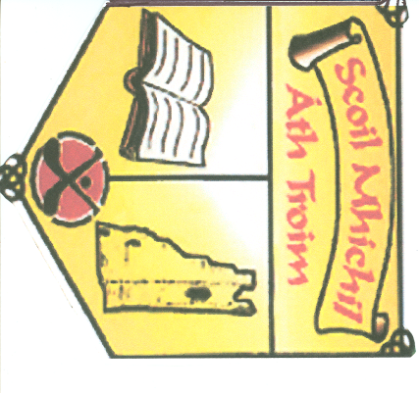

SCHOOL IMPROVEMENT PLAN FOR LITERACY

School Improvement Plan For Literacy
Strengths | Areas for Improvement
- Already achieving a good level of Literacy.  - Oxford Reading Tree is very successful.  - There is a well-stocked library and pupils take home a library book per week across all classes.  - Pupils are interested and engaged in reading and project work.  - We have a print rich environment.  - Draft, edit and redrafting are at the heart of the writing process.  - Support from special education team in school.  - Good cursive handwriting fostered.  - A variety of different teaching approaches used to cater for different learning styles.  - Results of assessments are used to inform teacher planning. | - Further develop our pupils’ reading skills and increase the number of pupils attaining above average in reading in annual standardised test.  - Adopt a more structured approach to teaching the writing genres.
Targets

- Increase the percentage of pupils attaining above average ( 50th percentile) in standardised reading test by 5% over the next three years.
- Reduce the percentage of pupils achieving between the 3rd to 16th percentile in standardised reading tests by 3% over the next three years.

Actions
- DEAR to be introduced daily for ten minutes.
- Creative Writing Display Wall to be introduced where work from each class will be displayed for a fortnight.
- One hour increase in time given to literacy each week.
- Acquisition of further sets of novels with each class reading three of four novels each year.
- SESE- Introduction of new SESE textbooks ( Small World) initially at 3rd and 4th class levels to be extended to 5th and 6th classes in 2014-2015.
- More structured approach to teaching of writing genres. All six writing genres will be taught each year .
Term 1: Recount and Narrative Writing.
Term 2: Procedural and Report writing.
Term 3: Explanation and Persuasive Writing
- Samples of pupils’ written work in each genre will be displayed.
- SALF folders will be introduced to encourage pupils to be more actively involved in assessing their own work.
- Introduction of Paired Reading within classes and Buddy Reading between junior and senior classes.
- Principal and Deputy Principal to attend CPD Literacy courses.

Monitoring/Evaluation
- When?
Ongoing evaluation of progress and successful implementation of plan at staff meetings.
Review Dates:- June 2013.
June 2014.
June 2015.
- Who ?
All staff.
- How?
Teachers’ observations/designed tasks, pupil work samples, standardised tests scores, self assessment folders and feedback from parents/pupils.

Success Criteria

Success will be based on the achievement of our targets.

