St. Michael’s Primary School and Centre for Autism,
Patrick Street,
Trim,
Co. Meath.

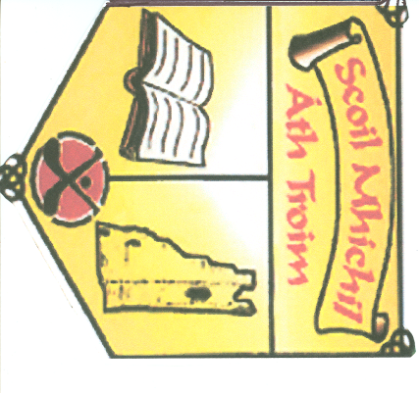

SCHOOL SELF-EVALUATION REPORT

Evaluation Period:- December 2014 - January 2015.
Report Date:-………3/2/15………………….

School Self Evaluation Report ( Mathematics )

Introduction
A school self-evaluation of teaching and learning in St. Michael’s Primary School, Trim, Co. Meath was undertaken during the period December 2014- January 2015. During the evaluation teaching and learning in the area of numeracy was evaluated.
The following sources of evidence were used to compile the findings of this report:
- Individual teacher reviews of practice in numeracy.
- Pupil’s work samples, copies, displays.
- Special Ed. support team observations.
- Staff ratings of school plans.
- Teacher questionnaires.
- Parental questionnaires.
- Pupil questionnaires.
- Feedback from Inspectorate incidental visit.

School Context
Patron: Bishop Michael Smith.
Principal: Mr. Fergal Fitzpatrick. ( Administrative).
Deputy Principal : Ms. Bríd Gorry. ( Administrative ).
Chairperson: Fr. Seán Henry.
Staff: Mainstream - 10 class teachers, 4 support teachers and 2 special needs assistants.
Centre for Autism- 6 class teachers and 16 special needs assistants.
Pupils: 278 pupils enrolled.
Initiatives: Green flag, school choir, tin whistles lessons, active school initiative, seachtain na
Gaeilge, sporting activities- hurling, football ,soccer and cross country running.

The findings
Learner outcomes:
- The overall attainment of our pupils with regard to mathematics is at a high standard in accordance with the learning outcomes of the Primary School Curriculum.
- The pupils’ knowledge , skills and understanding in numeracy are developing in a progressive manner as they move from class to class.
Learners’ experience:
- A safe stimulating learning environment is provided for the pupils in St. Michael’s.
- Classrooms are appropriately organised , are well resourced and orderly.
- The school is decorated with displays and centres of interest ( Good work wall ) that celebrate pupils’ work and support their learning in all curricular areas.
- Pupils enjoy their learning of numeracy and are motivated to learn.
- Pupils are enabled in maths class to communicate, work with others, investigate, experiment, analyse and problem solve.
Teachers practice:
- All teachers prepare short term and long term plans which are differentiated to cater for needs of all pupils. These written plans indicate learning outcomes, teaching methodologies and resources.
- Teachers provide monthly reports of pupils’ learning in numeracy.
- Teachers use a variety of approaches and methodologies across all classes in St. Michael’s.
- The school is inclusive and treats all pupils equitably and fairly.
- A positive code of behaviour is implemented in a fair and consistent manner.
- All classes are well managed and teacher- pupil , pupil- pupil interactions are respectful.
- Pupils’ efforts are affirmed.
Assessment:
A variety of AFL and AOL modes are used in all classes to monitor progress. Assessment results are analysed and used for screening, diagnosis of learning difficulties or identifying aspects of maths needing re-teaching. Class teachers and learning support teachers collaborate to ensure that supplementary teaching is available for children with learning difficulties.

Pupils engagement with learning.
77.5% of pupils reported that they like maths, 70% reported that they like engaging in problem solving activities and 47.5% reported that would be able to explain clearly to others how a maths problem was solved. Pupils reported that they enjoy a variety of maths lessons such as fractions , shapes , multiplication , money and maths games.
Parental Involvement
63.1% of parents returned the Parental Survey. Of those who returned the survey 80.5% reported that their children like maths, 74.6% reported that the maths their children are learning is at the right level of difficulty while 61% reported that they receive good information from the school about their childrens’ progress in maths.
Attainment in numeracy
The standardised Drumcondra maths test for May 2014 are as follows:
% of pupils at or below 2nd percentile 2%( Normal Distribution 2%)
% of pupils between the 3rd-16th percentile 9%( Normal Distribution 14%)
% of pupils between the 17th -50th percentile 23% (Normal Distribution 34%)
% of pupils between the 51st -84th percentile 24% ( Normal Distribution 34%)
% of pupils between the 85th -98th percentile 39%( Normal Distribution 14%)
% of pupils above the 98th percentile 2%( Normal Distribution 2%)
Summary of School Self Evaluation Findings
Our school has strengths in the following areas:
- Well stocked maths library.
- Mental Maths in every class daily for 10 minutes.
- Use of concrete materials and interactive whiteboards during maths class.
- Overall attainment in Drumcondra Maths test is above average.
- All pupils have individual mini whiteboards which encourages participation in maths class and enhances the reasoning process.
- Print rich maths language environment.
- Pupils are actively involved in assessing their own work through completion of SALF folders.
- Weekly assemblies an”Good Work Wall” affirm pupils’ efforts.

. The following area is prioritised for improvement:
- Problem solving.

Legislative and regulatory requirements
A legislative and regulatory checklist has been completed and St. Michael’s is fully in compliance.
The following policies need to be reviewed:-
- Data Protection Policy.
- Special Education Policy.
- RSE Policy.

