School Self Evaluation Report
Introduction:
The Focus of the evaluation
A school self-evaluation of teaching and learning in St. Michael’s Primary School was undertaken during the period Sept/2012 to June/2013. During the evaluation, teaching and learning in literacy was evaluated. The following sources of evidence were used to compile the findings of this report:
- Individual teacher reviews of practice in literacy.
- Staff rating of school plans.
- Pupil’s work samples, copies and displays.
- Pupil questionnaires.
- Standardised test results.
This is a report on the findings of the evaluation:
School Context
St. Michael’s is a twenty four teacher Primary School and Centre for Autism including five support teachers. St. Michael’s is a Catholic school under the patronage of the Bishop of Meath, with an administrative Principal and administrative Deputy Principal.
St. Michael’s mainstream classes are comprised of boys from 2nd to 6th class. We have girls enrolled in our Centre for Autism and pre-school class.

The Findings
Learner outcomes
- The overall attainment of the pupils with regard to literacy is remaining at a high standard in accordance with the learning outcomes of the primary school curriculum.
Learners’ experience
- Classroom learning environments provide for the needs of all pupils.
- The school and classroom environments supports, encourages and celebrates pupil learning and achievement for literacy.
- The pupils are enabled, when appropriate, to engage actively in their learning including working purposefully, being interested and participating. There is also a balance between teacher input and pupils input and pupils are encouraged to reflect on their learning.
- Pupils achieve the expected learning outcomes in literacy lessons.
- Pupils are enabled in literacy to communicate, work with others, engage in research, investigate, experiment, analyse and problem-solve.
Teachers Practice
- Long and short term plans are prepared . Teachers also provide monthly progress records of pupils’ learning in literacy.
- Necessary and relevant resources, materials and equipment are identified and sourced in advance of lessons.
- Teachers use a variety of approaches and methodologies across all classes in the school.
- The varying needs and abilities of pupils are catered for in the course of lessons through the use of differentiation.
- There is respect for all pupils regardless of their background, ability and aptitude. Pupils with special educational needs are treated in an inclusive and equitable manner.
Pupils engagement with learning
Of the 100 pupils who completed our literacy questionnaire 85% reported that they like reading while 77% found spellings easy to learn.
Assessment:
Teachers employ a large selection of assessment tools to assess learning in Literacy – observations, checklists, curriculum objectives, questioning, self-assessment, tests and standardised tests .The Micra T English standardised test is administered to all classes from second to sixth in May each year and results are reported to parents in the end of year report. NRIT tests are undertaken with second and fifth class each year in October.
Attainment in Literacy:
Standardised testing indicated that less pupils scored above average in Literacy than in Numeracy. We decided to prioritise Literacy in the current year 2012-2013.

Summary of the school Self-evaluation findings:
Our school has strengths in the following areas:
- Already at reasonable level of Literacy.
- Oxford Reading Tree is very successful.
- There is a well-stocked library and pupils take home a library book per week across all classes.
- Pupils are interested and engaged in reading and project work.
- We have a print rich environment.
- Draft, edit and redrafting are at the heart of the writing process.
- Support from special education team in school.
- Good cursive handwriting fostered.
- A variety of different teaching approaches used to cater for different learning styles.
- Results of assessments are used to inform teacher planning.

The following areas are prioritised for improvement:

- Further develop our pupils’ reading skills and increase the number of pupils attaining above average in reading in annual standardised test.
- Adopt a more structured approach to teaching the writing genres.

Legislative and regulatory requirements
A legislative and regulatory checklist has been completed and St. Michael’s is fully in compliance.
Reporting to parents on the progress of their children is in compliance with NCCA guidelines.

St. Michael’s Primary School and Centre for Autism,
Patrick Street,
Trim,
Co. Meath.

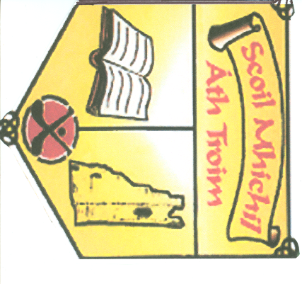

SCHOOL SELF-EVALUATION REPORT
Literacy

Evaluation Period: September 2012-June 2013
Report issue date: June 2013

